Bioploar Differential Amplifier

# Set up a differential amplifier with bipolar transistors according to the given circuit diagram.

For the experiments, the following devices were used:

|  |  |  |
| --- | --- | --- |
| Device Title | Inventory number | Number of device |
| MetraHit 26S | 1918 | - |
| MetraHit26S | 1916 | - |
| Power Device | 2312 | 3 |
| Metrawatt SE780 | 3524 | 5 |
| Gossen Metrawatt LSP-Konstanter 32K36R3 | 1973 | 4 |
| Ocilloscop TDS3012B | 1908 | 4 |
| Decade Resitance Model 8000 | 2226 | - |

Table 1 : device list

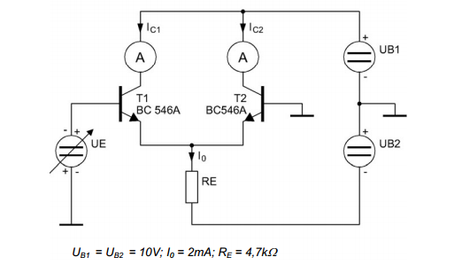

Picture 1 : main circuit

## 1-Plot the transfer-function Ic=f(uE) and Ic2= f(uE) using an XY recorder for the voltage range -300 mV <uin <+300 mV.

The result of the X-Y recorder is attached to the place.

## 2-Determine the offset voltage U0 out of the recorded transfer function .

Based on the characteristics, an offset U of =(8,5 )mV determined .

## 3-determine the slope rate S out of the recorded transfer function

The slope is determined in the curve:

## 4-capture the voltage graphs between both collector Terminals with a storage oscilloscope and determine the single ended Voltage Gain Vu,d.

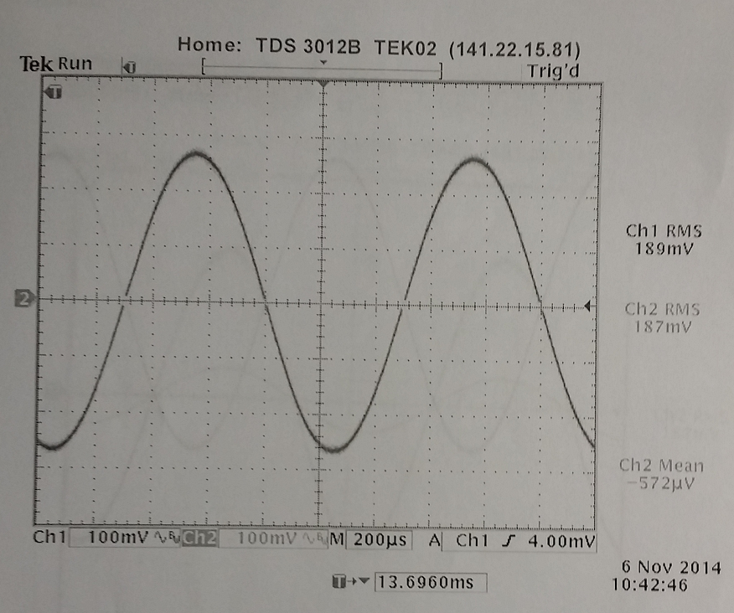

Picture 2: Voltage curve at T1 and t2

## 5-capture the voltage Graphs between both collector terminals with a storage oscilloscope determine the differential voltage gain V u,d

, .

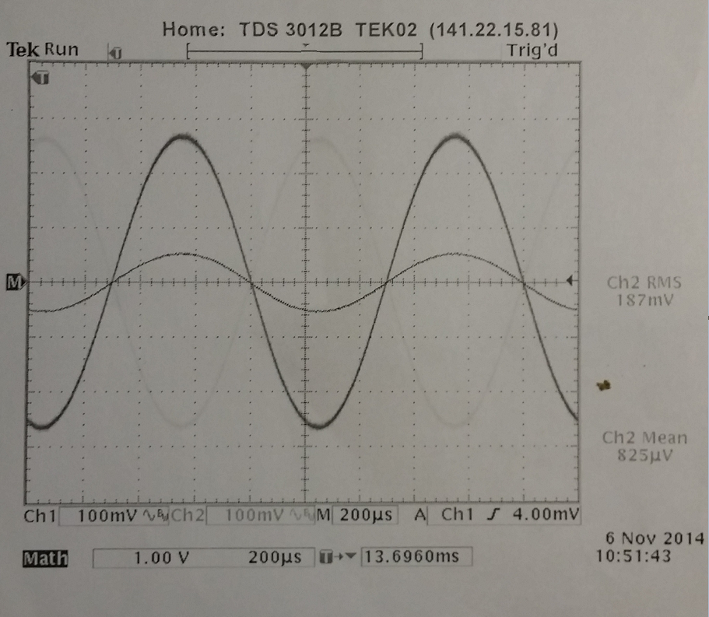

Picture 3 : Differential gain

**calculated :**

**:** **measured:**

## 6-invastigate the influence of I0 regarding the voltage gain :

## Measure the output voltage at Rc1 and determine the voltage gain with bisection and doubling of I0 .

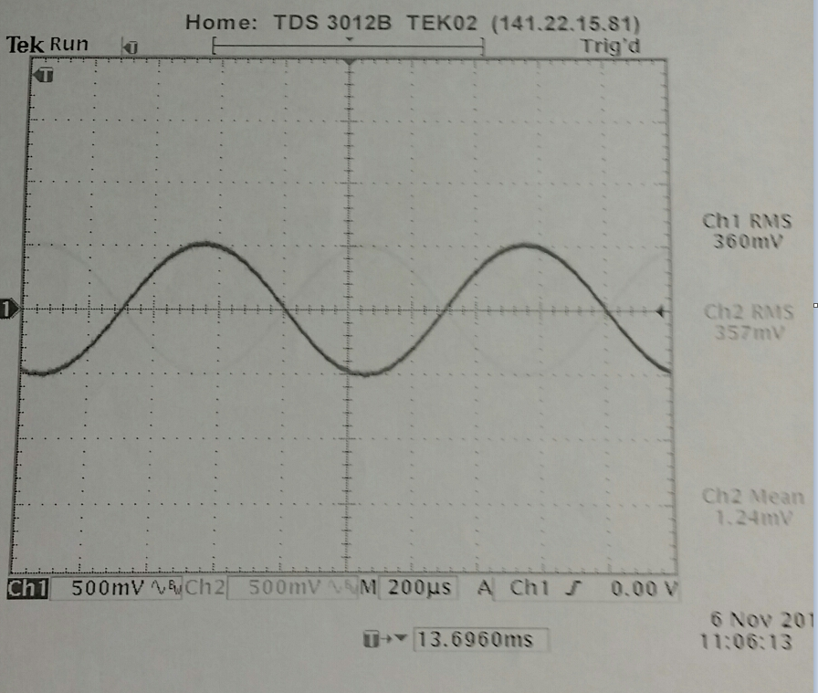

Picture 4 : two parallel resister

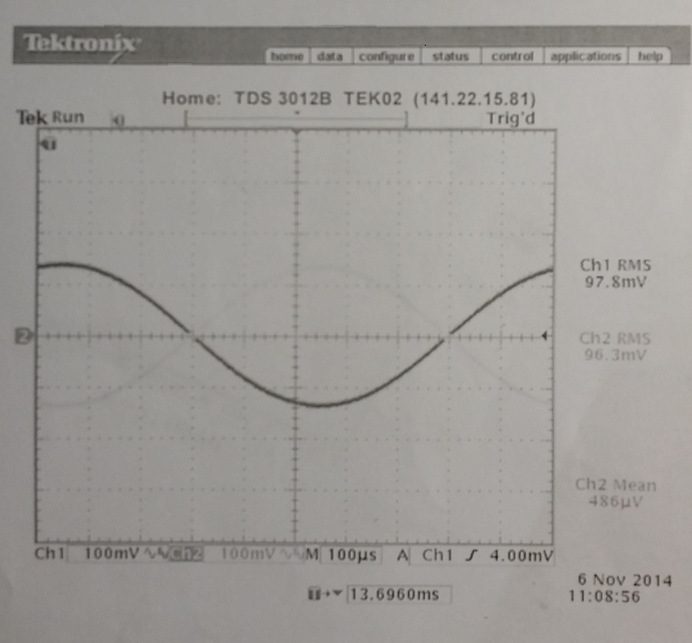

Picture 5 : two series resistor r= 4.7 ohm

7. Measure the common mode voltage gain Vu,gl :supply both transistors (their bases ) with Ue simultaneously and measure the output voltage gain Rc2 .

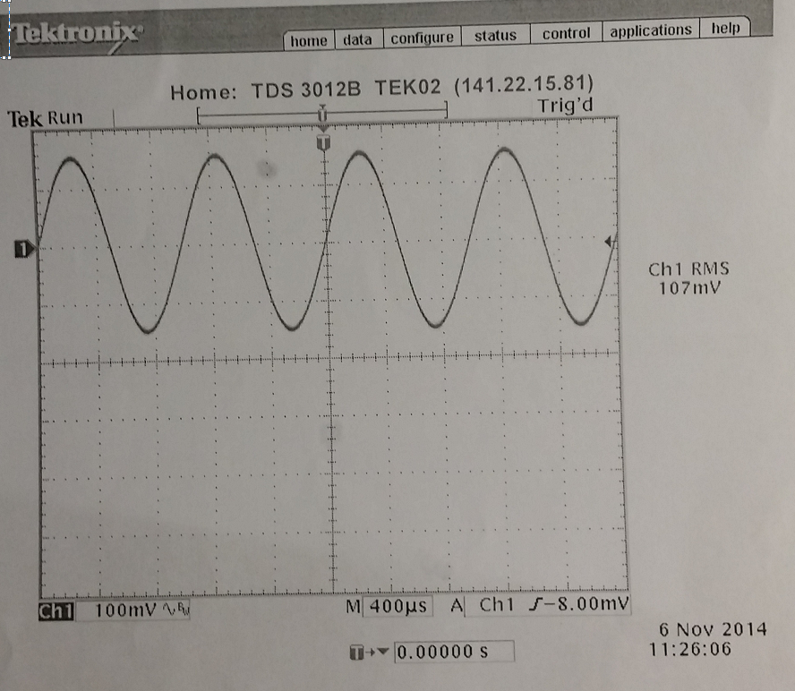

Picture 6 :

The common-mode gain is vcq=0,14 from the oscilloscope be read. The signal is greatly attenuated.